THE PUBLIC ACCOUNTANCY BOARD
4.0 Verifiable CPD Credits
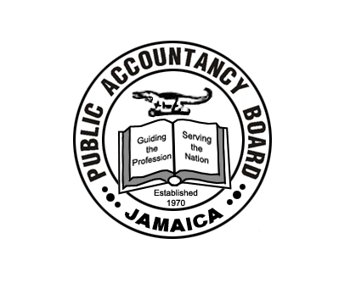

In Association with
The Institute of Chartered Accountants of Jamaica
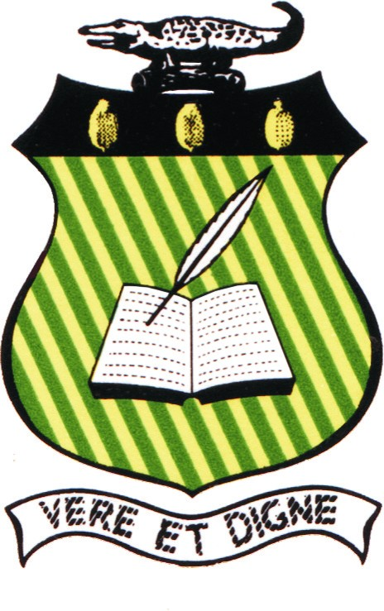

Present a Seminar on
Audit Practice Management & Regulatory Mechanisms to Counter Money-Laundering/Financing of Terrorism

November 06, 2010 at the Terra Nova All Suites Hotel

Programme

8:00 – 8:30am Registration

8:30 – 8:35am Greetings from ICAJ
Mr. Archibald Campbell, ICAJ President

8:35 – 8:50 am Welcome and Opening Comments
Mr. Eric Crawford, PAB President

8:50 – 9:50am Client Selection Issues/ Contracting with Clients/Reporting (Private Sector Perspective)
Mr. Emru Williams, Senior Manager – Assurance Practice,
PricewaterhouseCoopers (PWC)

9:50 – 10:50 am Client Selection Issues/ Contracting with Clients/Reporting (Public Sector Perspective)
Mrs. Ann Marie Rhoden, Deputy Financial Secretary, Public Enterprises Division, Ministry of Finance & the Public Service

10:50 – 10:55 am ICAJ Chairman’s Corner Presentation
Sandra Barnett, Chairman, ICAJ Welfare Fund Committee

10:55 - 11:30 am BREAK

11:30 – 12:30 pm Anti-Money Laundering/ Countering the Financing of Terrorism – Regulatory Mechanisms
Mr. Robin Sykes, Attorney at Law, Senior Legal Counsel, Bank of Jamaica

12:30 – 15:55 pm Panel Discussion
Presenters as listed above

12:55 – 1:00pm Closing Remarks
Mr. Compton Rodney, PAB Registrar

Moderator – Mr. Garth Kiddoe, Member, ICAJ CPD Committee
Question & Answer Session of 10 minutes is included in each presentation

