General Legal Council Anti-Money Laundering Examination Form

Instructions
Please read all instructions carefully before completing this form

Examination Period: __________________________________________

Name of Examiner: ___________________________________________

What is the purpose of this form?

The purpose of this form is to assess the level of compliance of Attorneys with the requirements of the Jamaican AML/CFT laws and regulatory guidance.

Who should complete this form?
This form shall be used by the General Legal Council and Accountants duly authorized to act as agents of the General Legal Council to conduct Examinations.

Please indicate below the type of examination to be conducted:

Routine Examination | ☐
Follow-up Examination | ☐
Random Examination | ☐
Special Examination | ☐

Notes to the Examiner:

- All examinations are risk-based. An examiner shall not proceed with an examination where he has determined that the Attorney has not categorized clients into “high” and “low” risk. The examiner shall advise the GLC in writing immediately.

- The Examination Form should be type-written and returned to the General Legal Council within ten (10) working days subsequent to the completion date of the examination.

- The routine examination period commences 1st January and ends 31st December of the following year.

- By undertaking this examination, the examiner understands and agrees that:

  - the examiner has assumed a direct duty to the General Legal Council as the Competent Authority;

  - the examination on which this report is based will be conducted diligently, impartially and with reasonable professional care;

  - full disclosure of all information relevant to the attorney’s compliance with the Jamaican AML/CFT laws will either be contained in or attached to the form;

  - the examiner will render further assistance as reasonably required by the General Legal Council in the course of its assessment of this form; and

  - a list of other Partners or Attorneys shall be attached if the space provided is inadequate

PART I:
PARTICULARS OF THE ATTORNEY/FIRM

- Name of Attorney/Firm:

- TRN:

- Street Address:

- Postal Address:

5. Telephone #: Fax #:

- E-mail Address:

- Number of premises / locations from which the attorney operates

8. | Address and contact | _________________________________________________________________________________
details for other

locations

- Number of Staff:__________________________

- Details of Partners over the examination period:

PARTNERS:

Name Position Appointment Date Cessation Date

- Details of Attorneys with the firm over the examination period?

ATTORNEYS:

Name Date Admitted Starting Date Ending Date

COMMENTS

(for General Legal

Council

use only)

PART II:

RISK-BASED CUSTOMER VERIFICATION PROCEDURES AND RECORDS

- Are there policies and procedures that categorize facilities into either "high" or "low" risk for money laundering showing the criteria used for such categorization?

Yes No

If the answer to Question 11 above is "No", the examiner should not proceed with the examination and should immediately notify the General Legal Council. The Attorney’s/Firm’s clients should be categorized into either "high" or "low" risk for money laundering.

13. Total number of client files on record

Number of high risk files

Number of low risk files

- Total number of client files examined

Number of high risk files

Number of low risk files

- Has the identity of each client for the file examined been established and verified in accordance with the AML law.

Yes No

- What number and percentage of files examined did not comply with question 15?

# %

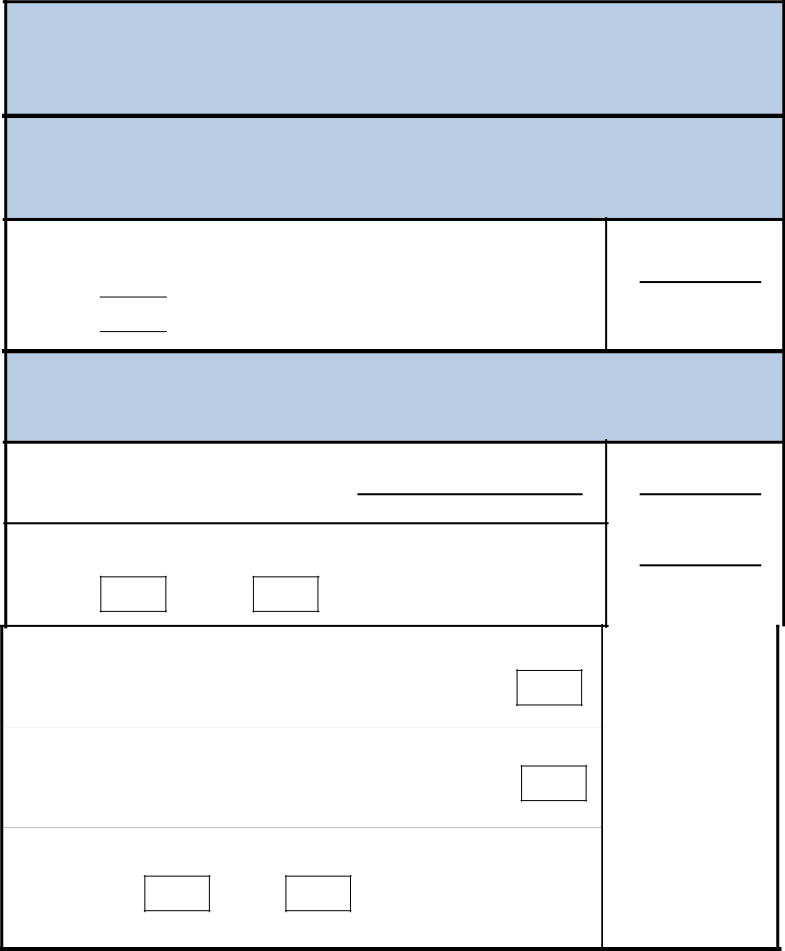
COMMENTS

(for General Legal

Council

use only)

PART III:

TRANSACTIONS RECORD KEEPING PROCEDURES

- What is the number of the client files examined that did not have all transaction records including verification in accordance with Jamaican Anti-Money Laundering law?

PART IV:

SUSPICIOUS TRANSACTIONS REPORTING PROCEDURES

- Name of Nominated Officer (NO)

- Has he/she confirmed he/she is aware of his/her responsibilities under the POCA (MLP) Regulations?

Yes No

- How many suspicious transactions reports have been made to the Nominated Officer during this examination period?

- How many suspicious transactions reports have been made to the Designated Authority during this examination period?

- Is there an internal AML/CFT staff training programme in place?

Yes No

If “Yes”, please attach list of the session topics and attendees.

COMMENTS

(for General Legal

Council use only)

PART V:

TRAINING AND STAFF AWARENESS PROCEDURES

- Has any staff attended/participated in AML/CFT training sessions conducted either locally or abroad during the examination period?

Yes No

If "Yes", please attach list of venue(s), participant(s), date(s) and proof of attendance

- Does the General Legal Council’s most current Guidance form part of the AML/CFT training and awareness procedures for staff?

Yes No

- Do internal AML/CFT compliance reviews take place?

Yes No

- What is the frequency of such reviews?

COMMENTS

(General Legal

Council

use only)

PART VI:

GENERAL COMMENTS/REPORT ON SPECIAL ISSUES

(Please attach additional information if space above is not sufficient)

Examination Date |  |  | Examination Period
 |  | Day/Month/ Year |  | Day/Month/Year to
 |  |  |  | Day/Month/Year
Name of Examiner |  |  | Signature of Examiner

